**Short description:**

Class Vehicle –an abstract class of vehicles.

Class Wheel- responsible of all methods or variable that relates.

Class Car inherence from vehicle– an abstract class of car.

Class Truck inherence from vehicle - an abstract class of truck.

Class Motorcycle inherence from vehicle - an abstract class of motorcycle.

Class FuelCar inherence from Car – a sealed class, create fuel car.

Class FuelTruck inherence from Truck - a sealed class, create fuel truck.

Class ElectricMotorcycle inherence from Motorcycle - a sealed class, create fuel motorcycle.

Class ElectricCar inherence from Car - a sealed class, create electric car.

Class ElectricMotorcycle inherence from Motorcycle - a sealed class, create electric motorcycle.

Class EngineType– an abstract class - responsible of all methods or variable relates to engine.

Class ElectricEngine inherence from EngineType – responsible of all methods or variable that relates to electric engine.

Class FuelEngine inherence from EngineType – responsible of all methods or variable that relates to fuel engine.

Enum EngineType – enum list of fuel /electric types.

Class CarOwnersInformation – contains all data about the owner of the vehicle.

Class OurGarage – contains all logic methods and data the garage system provided.

Class static VehicleTypeAndBuillder – contains the enum of vehicle type, returns the types and build a vehicle.

OutOfRangeException- inherence from class exception, exeption for invalid range.

Class UserInterface - responsible to relate between the logic of the program to the owner.

Class Program – contain Main (start point which runs class userInterface).

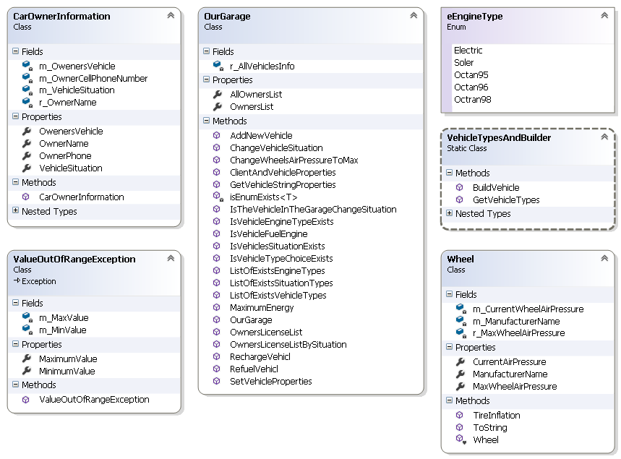**Logic Diagram:**

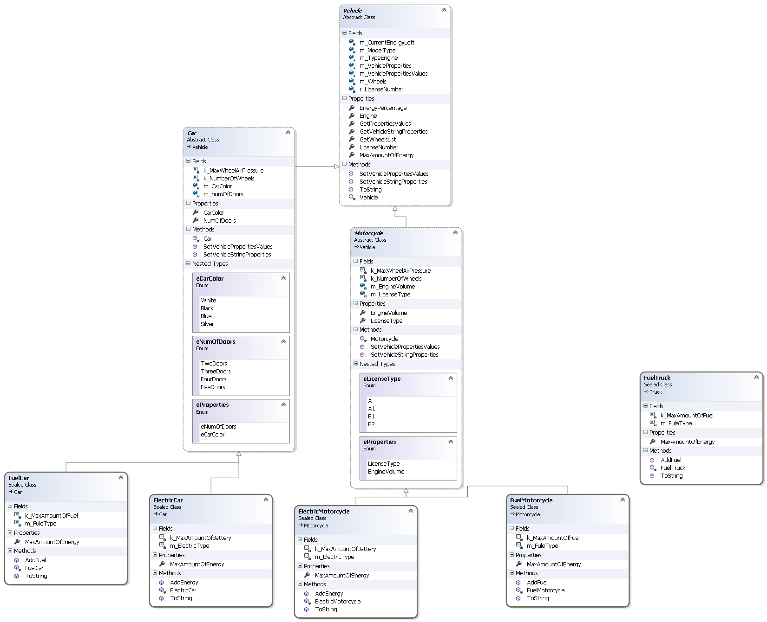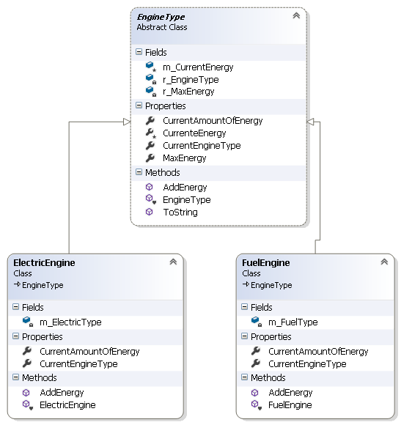

**UI Diagram:**

